BIACORE (3000, GE Healthcare)

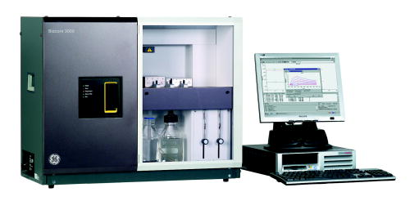
The Biacore 3000 system enables the comprehensive characterization of the biomolecular interactions, like Quantitative kinetic analysis (rate constants), Quantitative determination of affinity constants, Concentration determination, Determination of binding specificity and Thermodynamic measurements

Specifications:
1. Concentration measurement (For analysis times <15 minutes, precision ≤5% CV dose)
High molecular weight analytes (10⁴ -10⁶ g/mole)
a. Direct assay typically 10⁻⁵ - 10⁻⁹ M
b. Sandwich assay typically 10⁻³ - 10⁻¹¹ M
Low molecule weight analytes ( <5000 g/mole)
Inhibition assay typically 10⁻³ - 10⁻⁹ M
2. Affinity measurements at equilibrium
K_{A} typically 10⁴ - 10¹¹ M⁻¹
3. Kinetic measurements
High molecular weight analytes (10⁴ -10⁶ g/mole)
Ka: typically 10³ - 10⁷ M⁻¹ s⁻¹ and kd : typically 10⁻¹ - 5 × 10⁻⁶ s⁻¹
4. Detection Unit
Light source LED (Light Emitting Diode)
Wavelength 760 nm; Band width < 5 nm; Refractive index range 1.33-1.40 (0-70,000 RU)
Baseline drift typically < ±0.3 RU/minute
5. Data output
Noise typically < 0.3 RU RMS (10 Hz) : < 0.1 RU RMS (1 Hz)
Temperature range 4 - 40 °C (not lower than 20 °C below ambient temperature)
Temperature stability Better than ±3 × 10⁻³ °C/min
Temperature accuracy < ±0.5 °C (entire temp. range): < ±0.1 °C at 25 °C
6. Pumps
Flow rate range 1-5000 µl/min: (1-100 µl/min user-controlled) at an Increments Steps of 1 µl/min
Flow rate accuracy < ±2%: (1-100 µl/min, liquid at 25°C)
Flow rate precision < 1%: (1-100 µl/min, liquid at 25°C)
Pressure range < 0.2 MPa
7. Integrated µ-Fluidic Cartridge (IFC)
Flow cells number: 4
Injection volume to flow cell : 5 -750 µl, steps of 1 µl
Sample loop capacity 120 µl
8. Autosampler
Dispensing volume range 5-500 µl (including air segment)
Increments Steps of 1 µl
Accuracy < 1% deviation for volumes ≥50 µl
Precision
50 µl < 0.4% CV and 5 µl < 2% CV

Accessories

- Autosample vial kit
- Glass vials 16mm
- Plastic vials and cap 2ml
- Plastic vials 7mm

